|  |  |  |
| --- | --- | --- |
| 11 | **.**  **.**  **.**  **.**  **.**  **.**  **.**  **.**  **.**  **.**  **.**  **.**  **.**  **.**  **.**  **.**  **.**  **.**  **..**  **.**  **.**  **.**  **.** | **Information Systems Management** |

|  |  |
| --- | --- |
| CHAPTER LEARNING OBJECTIVE QUESTIONS |  |

11-1 What Are the Functions and Organization of the IS Department?

11-2 How Do Organizations Plan the Use of IS?

11-3 What Are the Advantages and Disadvantages of Outsourcing?

11-4 What Are Your User Rights and Responsibilities?

Learning Catalytics™ is a student response tool that helps you generate class discussion, customize your lecture, and promote peer-to-peer learning based on real-time analytics. Learning Catalytics uses students’ smartphones, tablets, or laptops to engage them in more interactive tasks.

|  |  |
| --- | --- |
| SO WHAT? |  |

## Poor Data Management at Facebook

1. *To what extent are social media platforms an important part of your daily interactions? Do you use a certain social media platform because your family or friends use it? Why do you think this is the case?*

Student responses will vary depending on their own social media usage patterns. The network effect is well known, however, meaning that people chose to use Web sites with more users who will provide them value.

1. *Are you one of the 87 million Facebook users who had their data shared with Cambridge Analytica? If so, did this situation bother you? Why or why not?*

Student responses will vary depending on their involvement with Facebook, the Cambridge Analytica scandal, and general attitude toward privacy.

1. *During Mark Zuckerberg’s hearings on Capitol Hill, it became clear that many politicians have minimal knowledge about how Facebook operates as a business. How does this present challenges for the creation of regulations that may be put in place to ensure that Facebook and other tech companies properly manage user data?*

Lack of knowledge about the tech industry on the part of legislators is a serious issue. We cannot expect appropriate, useful legislation from legislators who do not understand the environment, and we certainly don’t want legislation to be passed that does not correctly understand that environment.

1. *Why would Facebook offer a pay option? Would it be worth it to you to pay a monthly fee to access Facebook and know that your personal data would be protected? Why or why not?*

Student answers will vary since this is an opinion question. It may be worth pointing out that a $7 monthly fee is a small price to pay for personal data privacy protection, even for cash-strapped students.

|  |  |
| --- | --- |
| COLLABORATION EXERCISE 11 |  |

*Using the collaboration IS you built in Chapter 1 (pages 25–26), collaborate with a group of students to answer the following questions. If you haven’t built your collaboration IS yet, reread Collaboration Exercise 1 and Chapter Extension 10. Meet with your team and build a collaboration IS that uses tools like Google Docs, SharePoint, or other collaboration tools. Do not forget the need for procedures and team training.*

1. *Search the Internet to determine the power requirements for typical computing and office equipment. Consider laptop computers, desktop computers, CRT monitors, LCD monitors, and printers. As you search, be aware that a* watt *is a measure of electrical power. It is* watts *that the green computing movement wants to reduce.*

A Google or Bing search for “computer energy usage calculator” will find a number of useful tools. A good link is: <http://www.cosn.org/Initiatives/GreenComputing/EnergyUse/CalculatorIntro/tabid/4642/Default.aspx>, where you can find a Web-based energy calculator and a downloadable Excel spreadsheet.

The calculator shown here was originally obtained from the Columbia University Web site, but is no longer available from that source. This spreadsheet is available on request from this textbook’s publisher.

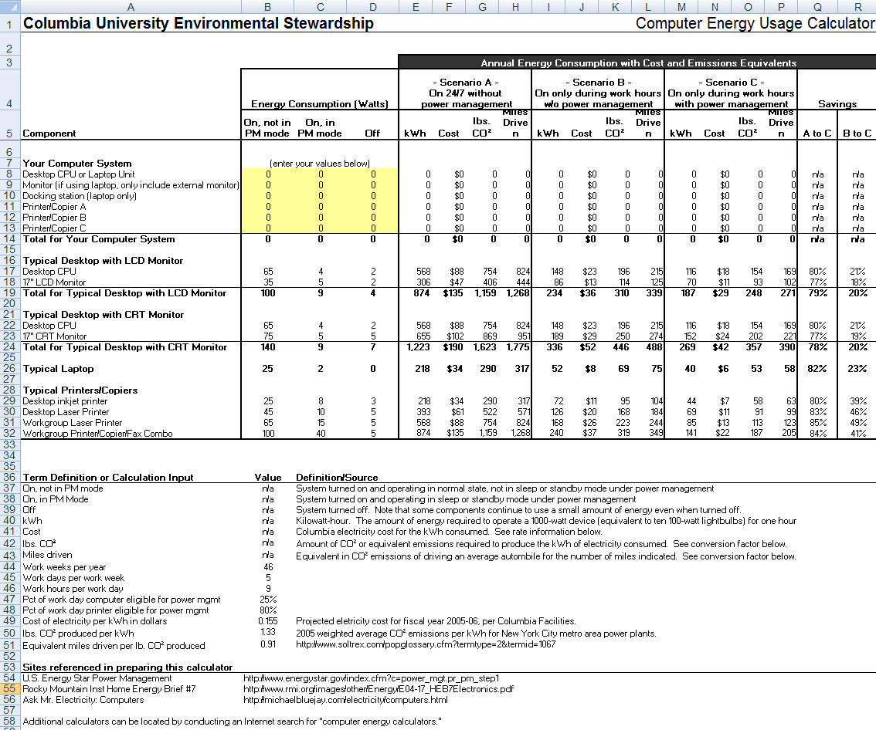

(LO: 1, Learning Outcome: Discuss best practices for selecting, evaluating, and managing information systems projects, AACSB: Analytic Thinking)

1. *Estimate the number of each type of device in use on your campus. Use your university’s Web site to determine the number of colleges, departments, faculty, staff, and students. Make assumptions about the number of computers, copiers, and other types of equipment used by each.*

Student answers will vary—for example, we can assume that a small school has:

* 350 desktops with LCD monitors
* 150 desktops with CRT monitors
* 100 laptops
* 300 inkjet printers
* 100 desktop laser printers
* 75 workgroup laser printers
* 25 workgroup printer/copier/fax combo

(LO: 1, Learning Outcome: Discuss best practices for selecting, evaluating, and managing information systems projects, AACSB: Analytic Thinking)

1. *Using the data from questions 11-4 and 11-5, estimate the total power used by computing devices and related devices on your campus.*

This spreadsheet uses the energy consumption estimates from the Columbia University Energy Usage spreadsheet in question 11-4. The number of each type of device has been inserted and the total energy consumption for each type of device is computed. The total kWh, cost, pounds of CO2, and miles driven are computed.

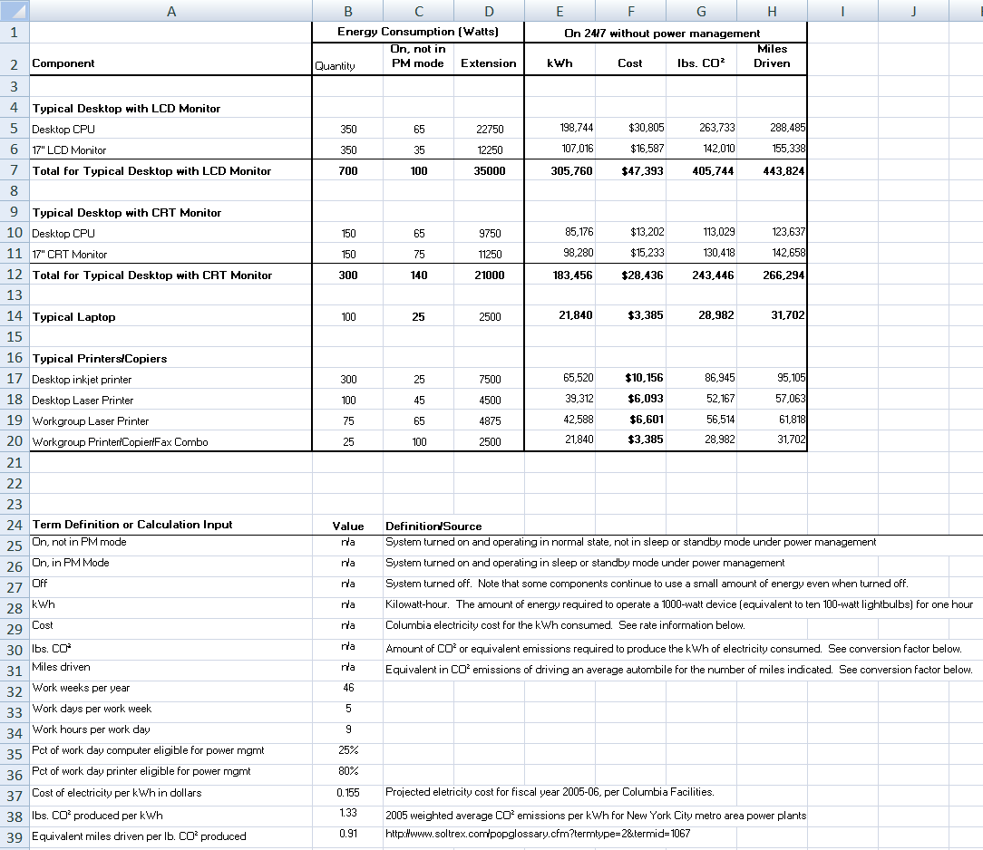

(LO: 1, Learning Outcome: Discuss best practices for selecting, evaluating, and managing information systems projects, AACSB: Analytic Thinking)

1. *A computer that is in screensaver mode uses the same amount of power as one in regular mode. Computers that are in sleep mode, however, use much less power, say 6 watts per hour. Reflect on computer use on your campus and estimate the amount of time that computing devices are in sleep versus screensaver or use mode. Compute the savings in power that result from sleep mode.*

The following spreadsheet compares the assumed inventory of computing devices in three scenarios—(A) on 24/7 with no power management (sleep mode); (B) on only during work hours with no power management; and (C) on only during work hours with power management. The savings between A and C range from 70 to 80 percent.

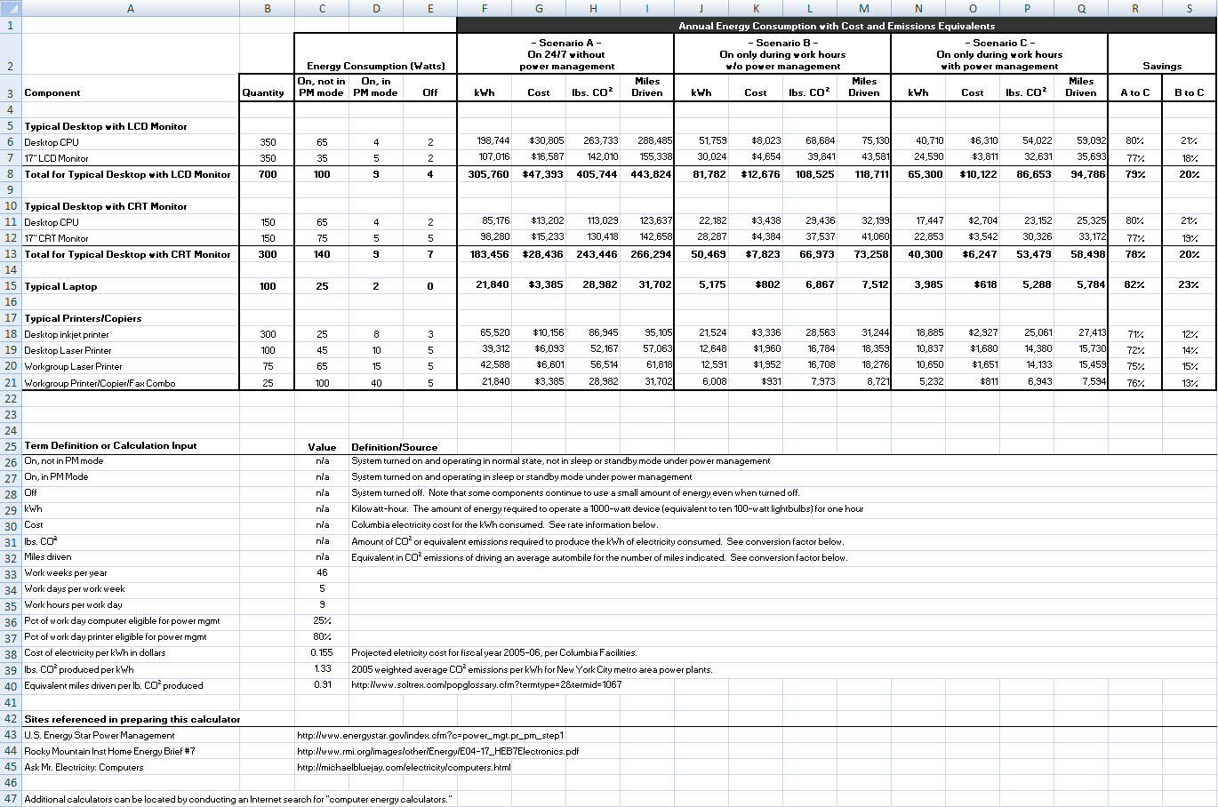

(LO: 1, Learning Outcome: Discuss best practices for selecting, evaluating, and managing information systems projects, AACSB: Analytic Thinking)

1. *Computers that are automatically updated by the IS Department with software upgrades and patches cannot be allowed to go into sleep mode because if they are sleeping they will not be able to receive the upgrade. Hence, some universities prohibit sleep mode on university computers (sleep mode is never used on servers, by the way). Determine the cost, in watts, of such a policy.*

Student answers will vary depending on the assumptions made for each university. For the assumptions made in item 2, the cost of no sleep mode allowed (in watts) is 341,056 (see Scenario A in spreadsheet above). This value is the total watts consumed by desktop and laptop computers on campus; printers were not included.

(LO: 1, Learning Outcome: Discuss best practices for selecting, evaluating, and managing information systems projects, AACSB: Analytic Thinking)

1. *Calculate the monthly cost, in watts, if:*
2. *All user computers run full time night and day*

Monthly cost in watts: 341,056 / 12 = 28421.3 (Scenario A above)

(LO: 1, Learning Outcome: Discuss best practices for selecting, evaluating, and managing information systems projects, AACSB: Analytic Thinking)

1. *All user computers run full time during work hours and in sleep mode during off-hours.*

Monthly cost in watts: 137,426 / 12 = 11,452.1 (Scenario B above)

(LO: 1, Learning Outcome: Discuss best practices for selecting, evaluating, and managing information systems projects, AACSB: Analytic Thinking)

1. *All user computers are shut off during nonwork hours.*

Monthly cost in watts: 109,585 / 12 = 9,132 (Scenario C above)

(LO: 1, Learning Outcome: Discuss best practices for selecting, evaluating, and managing information systems projects, AACSB: Analytic Thinking)

1. *Given your answers to questions 11-4 to 11-9, is computer power management during off-hours a significant concern? In comparison to the other costs of running a university, does this issue really matter? Discuss this question among your group and explain your answer.*

The analysis shown in the previous sections of this exercise clearly suggest that there are considerable cost savings to be gained from proper power management. In today’s environment of tight budgets, the cost savings arguments should be compelling. In addition, the spreadsheets in items 1, 3, and 4 show clear reductions in CO2 emissions with careful power management practices. Those who are concerned about the state of our environment will be impressed with those figures. If nothing else, the public relations value of those savings could work to benefit the university’s image.

(LO: 1, Learning Outcome: Discuss best practices for selecting, evaluating, and managing information systems projects, AACSB: Analytic Thinking)

|  |  |
| --- | --- |
| CASE STUDY 11 |  |

## Automating Labor

1. *How might the automation of labor provide a competitive advantage for forward-looking companies? How would this new competitive advantage be affected if all competitors in an industry adopted automated workforces?*

Automated labor can provide companies a competitive advantage if the company is able to use them to reduce costs and/or improve efficiency and effectiveness. When this technology is also adopted by competitors, the competitive advantage we have will go away, unless we are able to do things differently with our automated workforce that does enable us to attain and maintain our competitive advantage. What we do with the robots becomes more important than just replacing our human labor.

(LO: 2, Learning Outcome: Explain how IS can be used to gain and sustain competitive advantage, AACSB: Analytic Thinking)

1. *Automated workforces may replace certain types of jobs entirely. List three implications of an automated workforce for someone seeking a university education. Name three majors that might benefit from an automated workforce. Why might a university need to become nimbler in an era of automated labor?*

The availability of an automated workforce implies a number of things to people seeking a university-level education: (1) Focus on career paths that involve higher-level, non-routine cognitive tasks. Routine cognitive tasks will be allocated to the automated workforce. (2) Take every opportunity to you to develop your unique problem solving skills and your ability to innovate. (3) Consider career paths with a high need for human interactions (e.g., sales). Several majors that might benefit from an automated workforce include product design & engineering, sales/marketing, and law. In an era of expanding automated workforce, universities will need to adjust their offerings if a job/career path becomes a part of the automated workforces’ capabilities and no longer requires a university education to perform.

(LO: 2, Learning Outcome: Discuss the ethical and social issues raised by the use of information systems, AACSB: Analytic Thinking)

1. *List three new types of companies that might be created from an automated workforce (e.g., Uber without drivers). Why might these new companies put existing companies out of business?*

Student responses will vary, but a few ideas include companies that provide package delivery with self-driving trucks and robots to actually deliver the package to your door; grocery delivery via self-driving cars and robotic delivery ‘personnel’; lawn care/mowing services using robotic devices. These innovative ways of providing services could be performed as well or better than traditional services with human labor, at far cheaper prices; therefore, existing businesses may be threatened.

(LO: 2, Learning Outcome: Explain how IS can be used to gain and sustain competitive advantage , AACSB: Analytic Thinking)

1. *Government regulations like higher minimum wage rates, mandatory health insurance, and complex labor laws might make robots more attractive than human workers because they don’t come with these additional costs. Describe how government regulations could be altered to support human workers.*

Legislation can be used to influence behavior in ways that are deemed advantageous to society. To protect the human work force, the use of an automated workforce could be made less desirable financially through taxes or surcharges that could be imposed on them.

(LO: 2, Learning Outcome: Discuss the ethical and social issues raised by the use of information systems, AACSB: Analytic Thinking)

1. *Robots can be trained to do dangerous, stinky, and monotonous work that humans may not want to do. Name a job for which you think robots would be better suited than humans. Describe why you think humans would prefer to turn this job over to a robotic worker*.

Student responses will vary. One job that comes to mind is working in mines, which is very dangerous to the human workers.

(LO: 2, Learning Outcome: Discuss the ethical and social issues raised by the use of information systems, AACSB: Analytic Thinking)

1. *A personal robot could be purchased for your own personal use—to reduce your individual costs. It could do all your gardening, cooking, cleaning, home repairs, and so on. Explain why your personal income needs might change with an automated worker in your home. Can your personal robot meet all your needs?*

If a robot was available to perform many household tasks, the owner of the robot would have to incur little expense for those tasks after the initial robot purchase. The alternative of hiring human labor would involve no up-front costs but would have on-going and possibly increasing costs over time. The robotic option would also eliminate the need to find and retain the human worker in the first place.

(LO: 3, Learning Outcome: Discuss the ethical and social issues raised by the use of information systems, AACSB: Reflective Thinking)

1. *Robots don’t have the desire to stay alive, the desire to procreate, or the desire to improve their positions. How might the lack of these human characteristics prevent automatons from becoming our cybernetic overlords?*

Without any human-like motivations (e.g., greed, lust for power, etc.), the robotic workforce would simply do the tasks they are programmed to do.

(LO: 3, Learning Outcome: Discuss the ethical and social issues raised by the use of information systems, AACSB: Reflective Thinking)

For an example illustrating the concepts found in this chapter, view the videos in [mymislab.com](http://mymislab.com/).